Curriculum Vitae
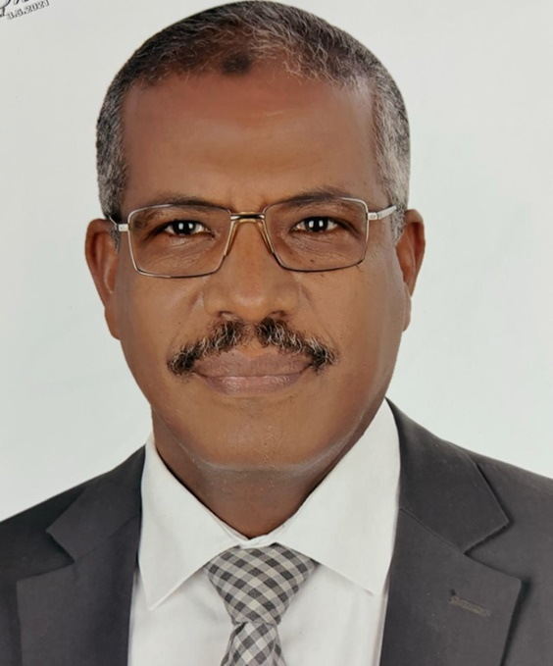

Prof. Hassan Abdellatef Aboelella Abdelkhalek

Professor of Urology, faculty of Medicine, Assiut University.

Vice president of Egyptian Urological Association (EUA)

Former Vice president of New Valley University for Postgraduate Studies and Research.

- Former Dean of the Faculty of Medicine, New Valley University.

- Former Vice Chairman of the Board of Directors of Assiut University Hospitals from 8th March 2018 till 14th June 2020.

- Former Deputy Director: of the Assiut University Main Hospital, from May 2012 – March 2015.

- Former Deputy Director: (by direct assignment from the president of Assiut University)of the Surgical Hospital Departments, Assiut University Hospital from Feb. 2011 - May 2012.

Personal Data

Name: Hassan Abdellatef Aboelella Abdelkhalek Date of birth: 14th Oct. 1963
Place of birth: Aswan
Nationality: Egyptian.

Marital Status: Married, has one daughter and two sons.
Religion: Muslim

Mobile: +2 01063010777 / 01223971284 / 01559005930
Home: +20882353570 / 0882367766
Fax: +20922935023

Residence: 13 Almadinah Almonawarah St. Assiut, Egypt.

Current position: Professor of Urology, Faculty of Medicine, Assiut University.

Email: h_a_aboulella@yahoo.com
hassan.abdelkhalek@med.au.edu.eg
ID number: 26310142800435 Assiut

Mobile: +201063010777 / 01559005930

Qualification and Education

- M.B.B.Ch.: Faculty of Medicine, Assiut University, September 1987.
- M.Sc. degree in Urology Faculty of medicine, Assiut University, 20th June 1992.
- MD degree of Urology Faculty of medicine, Assiut University, 25th Jan. 1998.

- Assistant Professor degree of Urology Faculty of medicine,
Assiut University, 30th March 2003.

- Professor degree of Urology Faculty of medicine, Assiut University, 30th March 2008.

Diploma

- Diploma in" Health Care Management Hospital Administration: Basic Advanced''
Ministry of Health, form 1/11/2010 to 30/10/2011

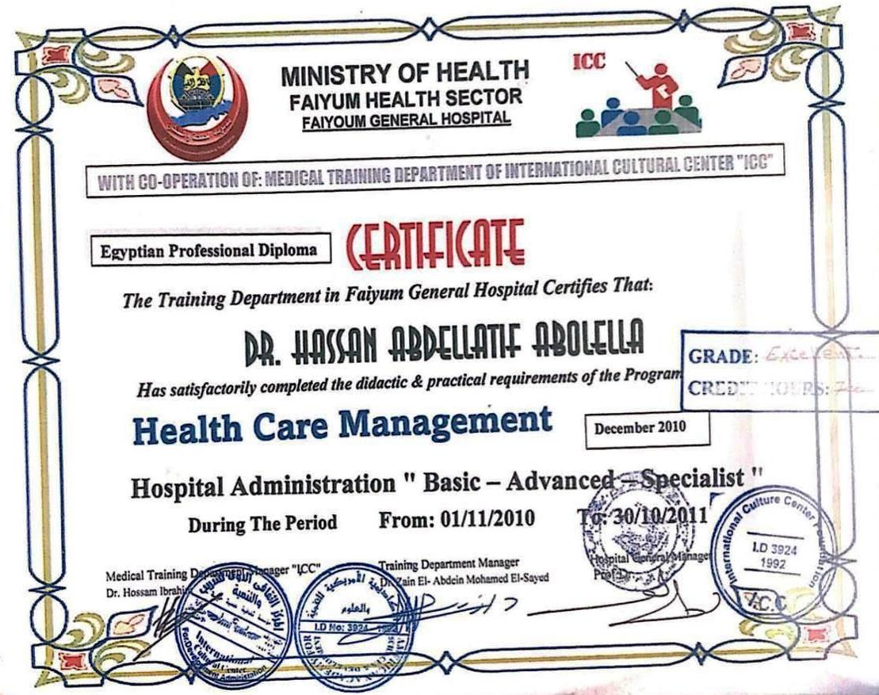

2. Diploma in" Medical Education 28/11/2023

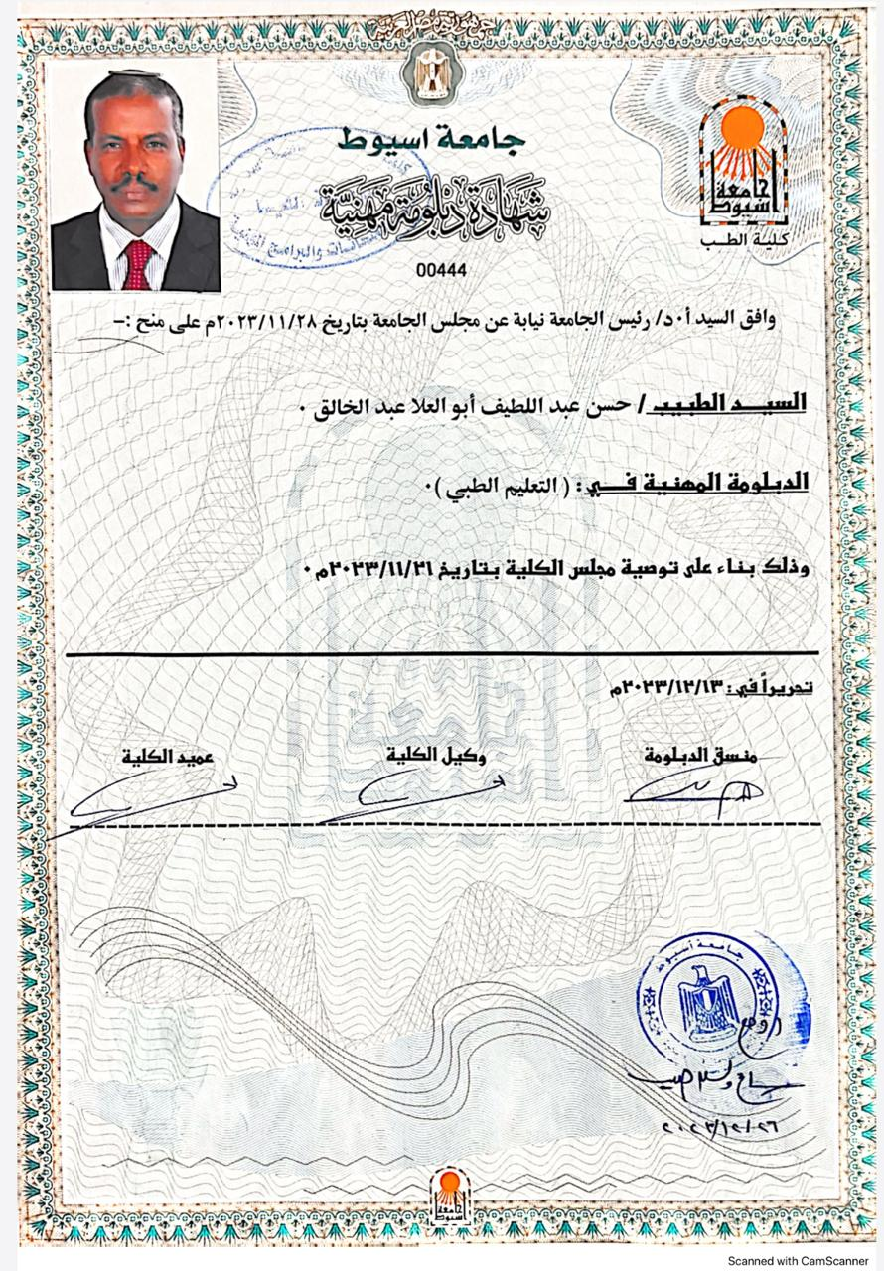

Administrative Positions

Current position:

Professor of Urology, Faculty of Medicine, Assiut University.

Past positions:
- Former Vice president of New Valley University for Postgraduate Studies and Research.
  - Former Dean of the Faculty of Medicine, New Valley University.
  - Former Vice chairman of the board of directors of Assiut University hospitals since March 2018 till June 2020
  - Former Deputy Director: of the Assiut University Main Hospital, from May 2012 – March 2015.
  - Former Deputy Director: (by direct assignment from the president of Assiut University)of the Surgical Hospital Departments, Assiut University Hospital from April 2011 - May 2012.

Experiences

- Professor of Urology, at Assiut University Hospital from 2008 till now.
- Assistant professor, at Assiut University Hospital from 2003 to March 2008.
- Lecturer of urology, at Assiut University Hospital from 1998 to March 2003.
- Assistant Lecturer of urology, at Assiut University Hospital since May 1992 to Dec. 1997.
- Urology resident, at Assiut university hospital, from March 1989 to April 1992.
- Internship, Assiut university Hospital, from March 1988 to Feb. 1989.

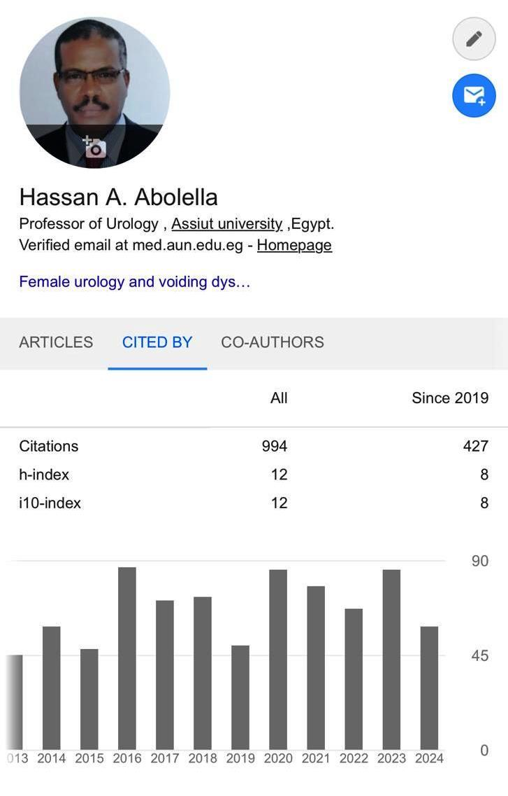
H - Index

Patent

Patent Number: 382 / 2011
Academy of scientific research. Ministry of higher education and scientific research.
Egypt
Title: Pelvi-ureteral stent.
This stent is composed of five parts; the first part is a malleable metallic part 15 mm in length with 2 mm diameter for introduction from the skin to the kidney. The second part is a non-fenestrated tube 12.5 cm in length to be positioned in the upper ureter. The third part is 12.5 mm in length, fenestrated tube to be positioned in the pelvi-calyceal system. The fourth part is a non- fenestrated tube 25 mm in length to be positioned outside the kidney. The fifth part is a fixed connection for urine bag. The tube can be manufactured from polyurethane in different sizes from 4-8 French.
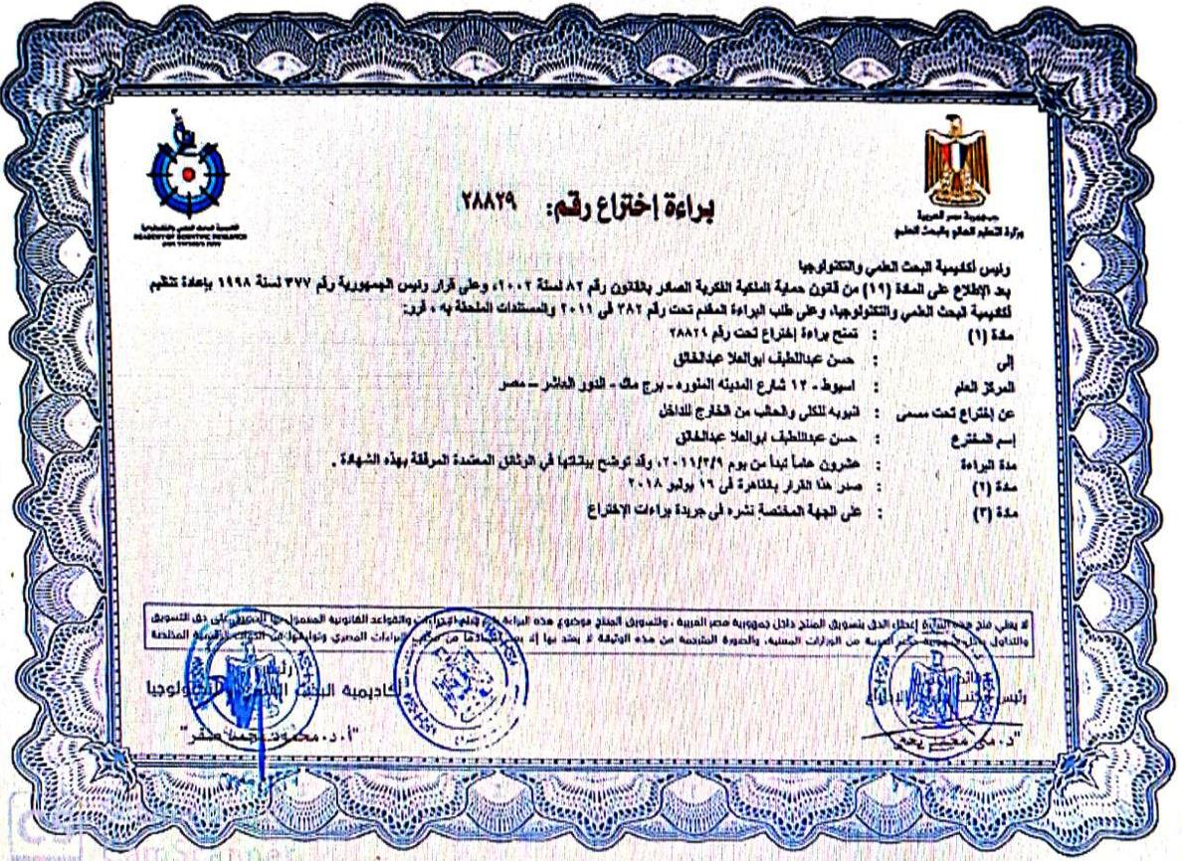

Scientific Publications

- Updates on vesicovaginal fistula, A systematic Review. Ahmed S. El –Azab, Hassan A Abolella, Mahmoud Farouk.
Arab Journal of Urology.04 April 2019
- Sacral neuromodulation of chronic pelvic pain: A meta–Analysis and systematic review of literature .Amr Mahran,Gina Baakini, Diasy Hassani, Hassan A Abolella, Ahmed Safwat, Sherif.A.El-Nashar.
International urogynaecology and obstetric journal. Jan 2019.
- Can Stone Composition be predicted by Plain X-ray and/or Non-contrast CT? A Study Validated by X-ray Diffraction Analysis :M Gad elmoula,Ahmed Moean,Ahmed Elderwy,Mohamed Abdelkader ,Ayman Elqady,Hassan Abolella, Esam Osman,
African Journal of Urology. Accepted in Jan 2019
- Isolated renal hydatid cyst misdiagnosed and operated as a cystic renal tumor. R A Gadelkarem , R Elqady A, Abd-Elshafy S, Hisham Imam, H A Abolella,
Medical principles and practice, vol. 27, No. 3, pp. 297-300, 2018
- Reliability of multiparametric prostatic MRI quantitative data in the evaluation of prostate cancer aggressiveness. Hiasam Atta, Tarek Elsaba, Hesham Hassan , Moamen Hafez, Hassan Abolella,Hisham Imam.
The Egyptian Journal of Radiology and Nuclear Medicine.48 ( 2017) 733-739.
- Levator ani defect : study of static MR images European Congress of Radiology 2016 | journal-article DOI: 10.1594/ECR2016/C-0948

- Hyperuricemia: A Possible Cause of Hemospermia .Adel Kurkar, Ahmad A. Elderwy,Sara M. Awad, Sherief Abulsorour, Hassan A. Aboul-Ella, Ahmed Altaher Urology, Volume 84, Issue 3, September 2014, Pages 609–612, 2014 .
- Minimally invasive percutaneous nephrolitholapaxy (PCNL) as an effective and safe procedure for large renal stones.
Mohamed F. Abdelhafez, Jens Bedke, Bastian Amend, Ehab ElGanainy, Hassan Aboulella, Magdy Elakkad, Udo Nagele, Arnulf Stenzl, David Schilling.
British Journal of Urology (BJR) International. Dec 2012, Vol. 110, No. 11c: E1022- E1026
- Maximum intensity projection images enhance the visualization of urinary calculi in the presence of contrast media or ureteric stents.
Hassan a Abolella , Hazem Youssef, Mohamad Omar, Hossam Youssef .
The Journal of urology 183 (4) April 2010

- Role of trans-catheter prostatic artery embolization in management of benign prostatic hyperplasia
Momtazt Allam, Abo EL-Kareem H. Abd Allah, Moustafa H.M. Othman, Hany Seif and Hassan Abolella.
Med. J. Cairo Univ., Vol. 85, No. 7, December: 2601-2611, 2017
- Potential biomarkers for differentiation of benign prostatic hyperplasia and prostate cancer.
El Melegy NT, Aboulella HA, Abul-Fadl AM, Mohamed NA.
Br J Biomed Sci. 2010; 67(3):109-12
- Detection of icaA, icaD Genes and Biofilm Production by Staphylococcus Aureus and Staphylococcus Epidermidis Isolated from Urinary Tract Catheterized Patients.
Gamal F Gad, Mohamed A Elfeky, Mostafa s El-Rehewy, Mona A Hassan, Hassan Abolella, and Rehab M Abd El-Baky,
J Infect DevCtries2009 Jun 1;3 (5): 342-51

- Single Puncture Percutaneous Nephrolithomy for Management of Complex Renal Stones.
Mahmoud M Shalaby, Medhat A Abdallah, Hassan A Aboul-Ella , Abdel –Monem A Elhagagy and Alaa A Abd-Elsayed.
BMC Res Notes. 2009 Apr 20;2:62, Presented as a poster presentation in Berlin, EAU 2006
- In Vitro Efficacy of Ureteral Catheters Impregnated with Ciprofloxacin, N- Acetylcysteine and their Combinations on Microbial Adherence.
Mostafa S El Rehewy, Ahmed Abolyosr, Mohamed A. Elfeky, Mona A. Hassan, Hassan A.Abolella, and R. M. Abd El-Baky, Ahmed Abolyosr, Gamal F Gad,
Clinical Medicine: Urology, 1 October 2009:21-8. Presented in AUA, 2009

- Effect of Ciprofloxacin and N-acetylcysteine on Bacterial Adherence and Biofilm Formation on Ureteral Stent Surfaces.
M. A. El-FEKY1, M. S. El-REHEWY, M. A. HASSAN, H. A. ABOLELLA, R. M. ABD El-BAKY and G. F. GAD.
Polish Journal of Microbiology 2009, Vol. 58, No 3, 261267

- The Use of Flexible Ureterorenoscopy in the Management of Suspected Upper Tract Hematuria.
H.A.Abolella, M.M.Osman, A.M.AL-Taher, A.M.Abdel-Latif, M.A.Shalaby.
Arab Journal of Urology, Vol. 5, No. 1, March 2007; 20-23

- Local Anesthesia for Transrectal Ultrasound Guided Prostate Biopsy. Y.M.Abdel- Salam, A.Kurkar, H.A.Aboul Ella, M.A.Sayed and A.M.Atia.
Arab Journal of Urology, Vol. 5, No. 1, March 2007; 32-35
- ESWL for Bladder Stones in Elderly Males, Indications and Precautions. Ahmad Abolyosr, Medhat A Abdalla, Ahmad A AL Taher,Hassan A Aboulella and Ahmed M Abdel-Moiem.
Arab Journal of Urology, Vol. 5, No. 2, June 2007; 9-11.

- Dynamic Magnetic Resonance Imaging in Evaluation of Female Pelvic Organ Prolapse.
Hassan Abolella,Gehansayd, Ahmed El Azab.
Egyptian Journal of Urology, Vol. (15). December 2007. Presented as a poster in Milan, EAU 2007
- Prospective Randomized Trial Comparing Tension-Free Vaginal Tape and Inside- out Transobturator Tape for Surgical Treatment of Female Stress Urinary Incontinence.
Abolella H.A, EL-AzabA.Sh, AL-Taher A.M, Kurkar A.A, Ait-Allah A.S.
Egyptian Journal of Urology, Vol. 14, No. 1, 2007; 10-15.

- Free-to-Total Prostate Specific Antigen Ratio, Total Sialic Acid and Cathepsin-D in Diagnosis of Benign Prostatic Hyperplasia and Prostate Cancer.
Hassan A Abolella,Nahed T El melegy.
Arab Journal of Urology, Dec. 2007.
- Tension-Free Vaginal Tape; A Minimally Invasive Treatment of Female Stress Urinary Incontinence.
Hassan A Abolella.
Egyptian Journal of Urology, Vol. 13, No. 2, 2006; 134-137.

- Insulin-Like Growth Factor-1 and Insulin-Like Growth Factor Binding Protein-3 in Benign Prostatic Hyperplasia and Prostate Cancer.
Hassan Abolella, Khadiga Abdel-Shafae, MadeehaYounis, Hesham Abdel Raheem and Mahmoud Aboul-Wafa. Arab Journal of Urology, Vol. 3, No. 1, March 2005; 39-43. Presented in World Congress of Endo-Urology, Amsterdam 2005.

- Role of MRI and MRU in Evaluation of Loin Pain during Pregnancy.
Abolella H.A, Al-Taher A.M, H.M.Imam, M.A.EL-Sharkawey, E.Abo-Elhamed and A.M Nasr.
Egyptian Journal of Radiology and Nuclear Medicine Vol XXXV, number 3, September 2004, presented in World Congress of Endo-Urology, Amsterdam 2005.

- Urodynamic Features of Charleston Pouch versus Modified T Neobladder.
H.Hammouda, A.A.Gaafar, M.A.Sayed and H.A.Abolella,
Egyptian Journal of Urology, vol. 12, No. 2, 2005; 87-90.
- Cosmetic and Functional Outcome of Tubularized Incised-plate (TIP), Urethroplasty.
Hassan A Abolella, Ahmed M AL-Taher, Hisham M Hammouda and Mohamad A Abdel- Aziz,
Arab Journal of Urology, Vol. 3, No. 3, September 2005; 44-47 Presented in World Congress of Endo-Urology, Amsterdam 2005
- Retroperitoneal Laparoscopic Nephrectomy versus Open Nephrectomy for Benign Renal Disorders; A Comparative Study.
A A Kurka, F G.Anany,A A Ebrahim, H A Abolella,
Arab Journal of Urology, Vol. 3, No. 3, September 2005; 12-16.
- Management of Penile Fracture.
Ahmed El -Taher, Hassan Aboul-Ella, Mohamed Sayed and Atef Gaafar,
The Journal of Trauma, Injury, Infection and Clinical Care, 2004; 56 (5):1138-40.
- Intralesional Verapamil Injection in Treatment of Peyronie’s Disease - Preliminary Results.
H A Aboul-Ella,A M El-Taher ,M A El-Akkad,M A El-Sharkawy,
African Journal of Urology, Vol. 9, No. 2, 2003; 53-58
- Non-Stented Holmium: YAG Ureteroscopic Management of Lower Ureteral Calculi,
H. A.Aboul Ella and O. A.Ibraheim,
African Journal of Urology, Vol. 8, No.3, Aug. 2002
- Management of Renal Trauma-Assiut Experience. H.A.Aboul-Ella,A.M-El-Taher, A.A.Gaafar and M.A.Sayed, African Journal of urology, Vol. 8, No.1, Feb.2002.
- Steinstrasse After Extracorporeal Shockwave Lithotripsy: Aetiology, Prevention and Management,
M.A.B.Sayed, A.M.EL-Taher,H A. Aboul-Ella and Shaker S.E.
British Journal Urology (BJU) International, Volume 88, 675-678, 2001
- Magnetic Resonance Urography in The Assessment of Obstructive Uropathy in Patients with Renal Failure,
H. A.Aboulella, M. A.Sayed, A. M.EL-Taher, H.M.Imam and Y. M.Badran,
Egyptian Journal of Radiotherapy, vol. XXXII, No. 3, Sept. 2001

- Prostatic Secretary Granules: An Additional Diagnostic aid to Distinguish Benign from Malignant Cells in Prostatic needle biopsies,
Hussien A.H.Gadalla and HassanA. Abolella,
Egyptian Journal of Pathology, Vol. 21, No. 2, Dec. 2001.

- Urodynamic Evaluation of Surgical and Endoscopic Treatment of Benign Prostatic Hyperplasia,
Atef.A.A.Gaafar E.Shaker, Hassan A.Aboul-Ella,
Minia Medical Journal, Minia University, January 2000.

- Three Steps Management of Irreducible Complete Procidentia Complicated by Vesicle Calculi-Gynecology. Case Report.
T.K.AL-Hussaini and H.A.Abol-Ella,
Journal of Obstetrics and Gynecology 1999, Vol., 19, No 5, 551-552.

Membership of Scientific Societies
- Member of the Egyptian Medical Syndicate.
- Egyptian Association of Urology (EUA), Active Member since 1992 till now
- American Urological Association (AUA), Active Member since 2006 till now.
- European Association of Urology (eau), Active Member since2003 till now.
- International Continence Society (ICS), Active Member since 2014 till now.
- Society International of urology (SIU), Active Member since 2004 till now.
- Arab Association of Urology (AAU).
- Pan Arab continence society (PACS), Active Member since 2004 till now.
- International society of genitourinary reconstruction surgeons (ISCURS) since 2017 till now.
- International alliance of Urolithiasis (IAU) since 2019 till now.

Supervising Master Thesis
  - Master thesis of Dr. Ahmed Farahat Hassan - titled: The efficacy of botulinum toxin in Overactive Bladder. 19-11-2017
  - Master thesis of Dr. Ayman Asem Abdel Moghney - titled: Radiodensity by multislice computed tomography and x-ray diffraction analysis of urinary stones. 11-2-2014
  - Master thesis of Dr.Mamdouh Ali Mohamed - titled: Patten or nocturnal enuresis in primary school children in rural and urban areas of Assiut governorate. Essay ,21-1-2013
  - Master thesis of Dr. Asmaa Mohamed Mohamed - titled: Primary nocturnal Enuresis: a multidisciplinary study. 18-7-2011
  - Master thesis of Dr. Ahmed Mohamed Helmy - titled: Complications of renal transplantation. Essay 19-4-2011
  - Master thesis of Dr.Mohamed Ahmed Abdel Rahman - titled: Hypogonadism in male. Essay 14-3-2010
  - Master thesis of Dr .Shady Mohamed Taleb Ellaham - titled: Management of non-muscle invasive transitional cell cancer of urinary bladder. Essay 20-7- 2008
  - Master thesis of Dr. Ahmed Mohamed Moaeen - titled: Management of vesicoureteral reflux in children .Essay 17-9-2006
  - Master thesis of Dr .Taha Mohamed Ebrahim - titled: Intestinal urinary reservoirs after radical cystectomy .Essay 18-7-2006
  - Master thesis of Dr. Nahed Ahmed mohamed – titled: Study Of Some Biochemical indices in Patients With Benign Prostatic hyperplasia and prostate cancer .12-1-2003
  - Master thesis of Dr. Mahmoud Mohamed Shalaby – titled: Percutaneous Nephrolithotomy. 21-12-2003
  - Master thesis of Dr. Mahmoud abolwafa Mahmoud – titled: Insulin like growth factor-1 and insulin like growth factor binding protein-3 in benign prostatic hyperplasia and prostate cancer. 21-7-2002

  - Master thesis of Dr. Hazem Mohamed Osman – titled: Magnetic resonance urography in urologic practice. 18-6-2000

Supervising Doctoral Thesis

- Doctoral thesis of Dr. Mahmoud Farouk Ali - titled: Posterior tibial nerve stimulation versus botulinum toxin A injection for treatment of refractory overactive bladder, a prospective randomized study 21-6-2016.
- Doctoral thesis of Dr.Amr Abdallah Mahran - titled: Impact of aging on recovery and stem cell therapy of stress urinary incontinence experimental study. 11-2-2014
- Doctoral thesis of Dr. Momtaz Thabet Alaam - titled: Role of trans–catheter prostatic artery embolization in management of benign prostatic hyperplasia .23-9-2015
- Doctoral thesis of Dr. Amr Abdel Fatah Gaber - titled: Minimally invasive percutenous nephrolithotomy in management of upper urinary tract calculi
.20-3-2012
- Doctoral thesis of Dr. Ahmed Reda Mohamed - titled: Hand-assisted laparoscopic donor nephrectomy. 20-3-2012
- Doctoral thesis of Dr. Mohamed Farouk Mohamed - titled: The use of the minimally invasive percutaneous nephrolitholapaxy in the management of large sized upper urinary calculi .20-10-2009
- Doctoral thesis of Dr .Gehan Sayed Ahmed - titled: Magnetic resonance imaging in evaluation of female pelvic floor weakness.
21-11- 2004
- Doctoral thesis of Dr. Adel Korkar Abdallah Abdel Motaleb - titled: The Use Of retroperitoneal laparoscopy in the treatment of some benign upper urinary tract diseases .23-9-2001

Reviewer
1. Asian Journal of Urology.
2. Urology Annals.
3. Arab Journal of Urology.
4. African Journal of Urology.
5. Egyptian Journal of Urology.
6. Al Azhar Medical Journal.

Conferences

  - Annual Meeting of American Urological Association ( AUA ) in Chicago,2-6 May 2019
  - The international alliance of urology (IAU) Annual Meeting in Guangzhou, China. 30-31 March 2019.
  - Annual Meeting of Pan- Arab continence Society Cairo. Feb 2019.
  - Annual Meeting of American Urological Association (AUA) in san-Francisco, 2018
  - Annual Meeting of American Urological Association (AUA) in Boston 2017
  - Annual Congress of European Urological Association (EAU) in London, United Kingdom, 2017.
  - Annual Meeting of American Urological Association (AUA) in San Diego, CA 2016.
  - Annual World Congress of Endourology &SWL in Cape-Town, 2016.
  - Annual Meeting of American Urological Association (AUA) in New Orleans, LA 2015.
  - Annual Congress of European Urological Association (EAU) in Paris, France 2015.
  - Annual Meeting of Pan- Arab Continence Society 2013 in Daubi.
  - The Annual Congress of European Urological Association (EAU ) in Spain 2012.
  - Annual Congress of European Urological Association (EAU) 2011.
  - Annual Meeting of American Urological Association (AUA) in Chicago 2009.
  - Annual Congress of European Urological Association (EAU) Milan, Italy 2008.
  - Annual Meeting of International Continence Society (ICS) in Cairo, Egypt 2008.
  - Annual Meeting of Pan- Arab Continence Society in Alexandria-Egypt 2007.
  - The Annual Congress of European Urological Association (EAU) Berlin, 2007.
  - Annual World Congress of the International Society for Sexual Medicine in Cairo, 2006.
  - Annual World Congress of Endourology &SWL in Amsterdam 2005.

  - Annual (EAU) Congress of the European Association of Urology 2005.
  - Eulis Symposium of urolithiasis (EAU) in Istambul, Turkey, 2003.
  - The Annual Congress of Egyptian Association of Urology (EAU) from 1991 till 2023.
  - International alliance of Urolithiasis (IAU) since 2019 till now.
  - American Urological Assoication Annual meeting 2006, 2009, 2011, 2015, 2018.
  - 13th annual conference of international alliance of urolithiasis in China 2024.

Visiting professor

- Visiting Professor of The Guangzhou University, Urology dep. 8-13 Sept., 2024. The first affiliated hospital of Guangzhou university, China.
- Visiting Professor of The Guangzhou University, Urology dep. 22-29 March. 2019, The first affiliated hospital of Guangzhou university, China.
- The Third IAU Workshop on PCNL&F-URS in the first affiliated hospital of Guangzhou university, March 27-29 ,2019, Guangzhou, China.
- Visiting Professor of The UniveristatsKlinikum Halle Saale, Germany, March 1-6 ,2012.
- A.M.I. Atoms-Adjustable Transobturator Male incontinence System Workshop in Halle (Saale), Germany 2012.
- Workshop on Stone Management in Endourology, in Amsterdam October 2012.
- Workshop on PCNL&F-URS in Annual Meeting of American Urological Association (AUA) in Chicago 2009.
- Lower urinary tract dysfunction and urodynamic of (ESU) course in Milan, Italy 2008.
- Vaginal surgery for urologists of (ESU) course in Milan, Italy 2008.

Honors

  - One of the best personalities in 2020, the best for the position of: Vice chairman of the board of directors of Assiut University, on the official media page in Assiut Governorate, he supported everyone and helped them as much as he could.
  - The ideal doctor in the Arab Republic of Egypt 2023.
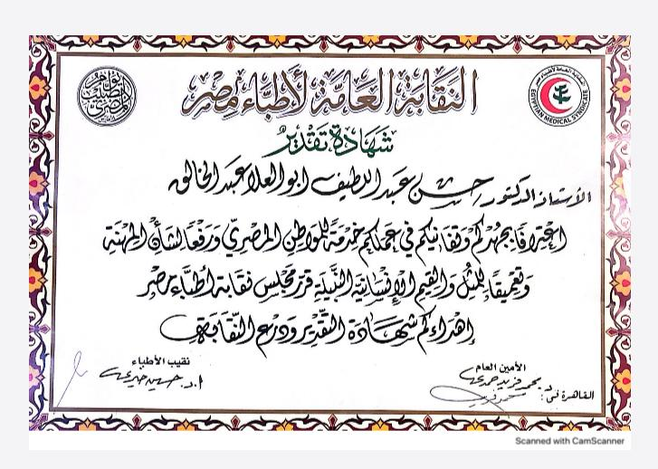

Reference Professors

References

Prof. Mohamed A. Shalaby: Professor of Urology, Assiut University, Assiut University, former president of Egyptian Urological Association.

Prof. Hassan Abol-Enein: Professor of Urology, Urology and Nephrology Center, Mansoura University, President of Egyptians Urological Assoication.

